 | 7.0.7 Editors - 3D Viewport - Mesh Object - Weight Paint Mode - Brushes context menus
Table of content
Brushes context menus 1
Weight 1
Size Pressure 1
Radius 1
Size Pressure 1
Use Unified Radius 2
Strength 2
Size Pressure 2
Use Unified Radius 2

Brushes context menus
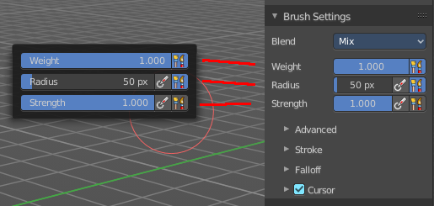
Call this menu with double right click in the 3D viewport. You need to be in Weight Paint mode with a mesh object.
In Weight Paint mode you will call a context menu with the sliders from the Brush settings.

Weight
Adjust the strength of the weight painting.

Size Pressure
The first button behind the edit box enables tablet pressure sensitivity for radius.

Radius
The Radius edit box allows you to adjust the radius of the brush.

Size Pressure
The first button behind the edit box enables tablet pressure sensitivity for radius.

Use Unified Radius
The second button behind the edit box enables global radius size. Any modification at the radius will also modify the radius value for other paint tools.

Strength
The Strength edit box allows you to adjust the strength of the brush.

Size Pressure
The first button behind the edit box enables tablet pressure sensitivity for radius.

Use Unified Radius
The second button behind the edit box enables global radius size. Any modification at the radius will also modify the radius value for other paint tools.

